Palindrome mu Değil mi ?

Yasin KARAÇAM Veri Yapıları - I Ödev 1

Singly Linked List :

#include <stdio.h>

#include <stdlib.h>

#include <stdbool.h>

#include <string.h>

struct Node {

char data;

struct Node* next;

};

bool isPalindrome(struct Node* head) {

struct Node* temp1 = head;

struct Node* temp2 = NULL;

struct Node* reverse = NULL;

while (temp1 != NULL) {

struct Node* new_node = (struct Node*)malloc(sizeof(struct Node));

new_node->data = temp1->data;

new_node->next = reverse;

reverse = new_node;

temp1 = temp1->next;

}

temp1 = head;

temp2 = reverse;

while (temp1 != NULL && temp2 != NULL) {

if (temp1->data != temp2->data) {

return false;

}

temp1 = temp1->next;

temp2 = temp2->next;

}

return true;

}

void push(struct Node** head, char new_data) {

struct Node* new_node = (struct Node*)malloc(sizeof(struct Node));

new_node->data = new_data;

new_node->next = *head;

*head = new_node;

}

void printList(struct Node* head) {

struct Node* temp = head;

while (temp != NULL) {

printf("%c", temp->data);

if (temp->next != NULL) {

printf(" -> ");

}

temp = temp->next;

}

}

int main() {

struct Node* head = NULL;

char input[100];

printf("Bir kelime girin: ");

fgets(input, sizeof(input), stdin);

input[strcspn(input, "\n")] = 0;

for (int i = strlen(input) - 1; i >= 0; i--) {

push(&head, input[i]);

}

printf("Tek Bağlı Liste: ");

printList(head);

if (isPalindrome(head))

printf("\nListe bir palindromdur.\n");

else

printf("\nListe bir palindrom değildir.\n");

return 0;

}

Doubly Linked List :

#include <stdio.h>

#include <stdlib.h>

#include <stdbool.h>

#include <string.h>

struct Node {

char data;

struct Node* next;

};

bool isPalindrome(struct Node* head) {

struct Node* temp1 = head;

struct Node* temp2 = NULL;

struct Node* reverse = NULL;

while (temp1 != NULL) {

struct Node* new_node = (struct Node*)malloc(sizeof(struct Node));

new_node->data = temp1->data;

new_node->next = reverse;

reverse = new_node;

temp1 = temp1->next;

}

temp1 = head;

temp2 = reverse;

while (temp1 != NULL && temp2 != NULL) {

if (temp1->data != temp2->data) {

return false;

}

temp1 = temp1->next;

temp2 = temp2->next;

}

return true;

}

void push(struct Node** head, char new_data) {

struct Node* new_node = (struct Node*)malloc(sizeof(struct Node));

new_node->data = new_data;

new_node->next = *head;

*head = new_node;

}

void printList(struct Node* head) {

struct Node* temp = head;

while (temp != NULL) {

printf("%c", temp->data);

if (temp->next != NULL) {

printf(" -> ");

}

temp = temp->next;

}

}

int main() {

struct Node* head = NULL;

char input[100];

printf("Bir kelime girin: ");

fgets(input, sizeof(input), stdin);

input[strcspn(input, "\n")] = 0;

for (int i = strlen(input) - 1; i >= 0; i--) {

push(&head, input[i]);

}

printf("Tek Bağlı Liste: ");

printList(head);

if (isPalindrome(head))

printf("\nListe bir palindromdur.\n");

else

printf("\nListe bir palindrom değildir.\n");

return 0;

}

Çıktı Ekran görüntüleri

1. Tek bağlı Liste :
2. Doğru örnek :

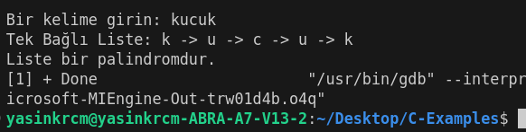

1. Yanlış örnek :

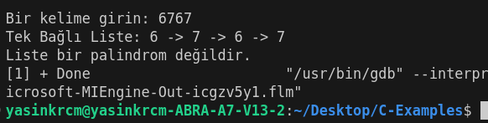

1. Çift bağlı liste :
2. Doğru örnek:

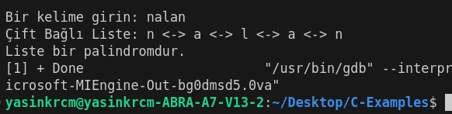

1. Yanlış örnek:

